**Student Have To Prepare Report In Format**

1. Add Task Description
2. Attach Screenshot Of Output.
3. Describe Widget/Algorithm Used In Task
4. Add Report In Your Task Zip File

**Sample Example :**

1. **Task Description**

Build a currency converter app that uses **real-time exchange rates** from the [fawazahmed0/currency-api](https://github.com/fawazahmed0/currency-api) to convert amounts between different currencies. The app also integrates a **flag API** to display the corresponding country flag for selected currencies, enhancing the visual experience.

1. **Task Output Screenshot**

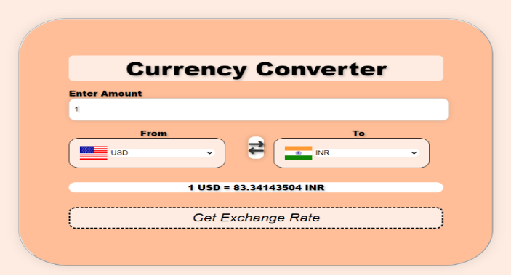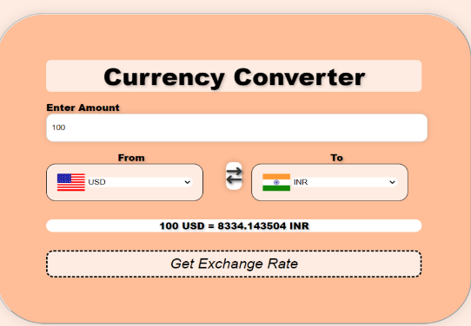

1. **Widget/Algorithm Used In Task**

* Skills: html, CSS, JavaScript, API
* Open index.html in your web browser.
* Select the base currency and target currency from the dropdown menus.
* Enter the amount to convert.
* The converted amount will be displayed instantly.